Ideation Phase

Define the Problem Statements

|  |  |
| --- | --- |
| Date | 19 September 2022 |
| Team ID | PNT2022TMID51641 |
| Project Name | Project – NEWS Tracker application |
| Maximum Marks | 2 Marks |

# Problem Statement:

Rahul is a busy businessman who needs to read news on the go without any hassles while travelling because he considers carrying around a physical newspaper a nuisance to him and the people around him. Rahul needs to read needs to read news in such a way that he doesn’t have to worry about ever buying physical newspapers or carrying with him everywhere. Something which should fit in the palm of his hands, which he could carry everywhere access from everywhere, something digital such as an application hosted on the internet which could be accessed from any device that is connected to the internet. Such as Smartphones and computers.

# Customer Problem Statement Template:

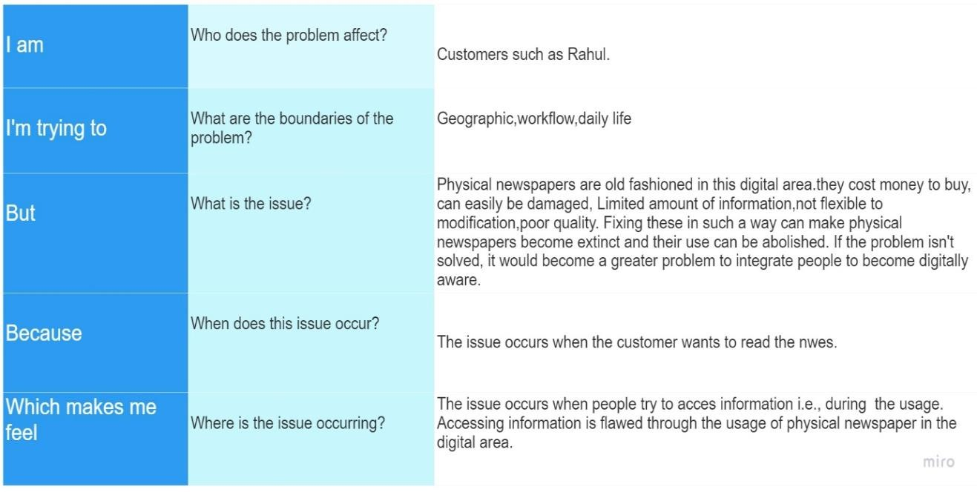

Example:

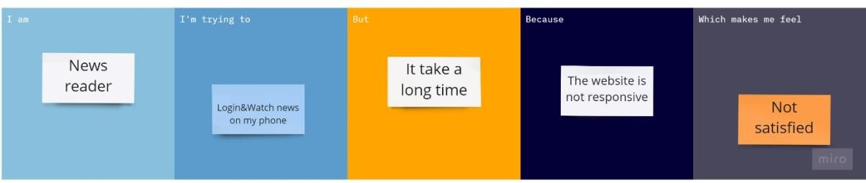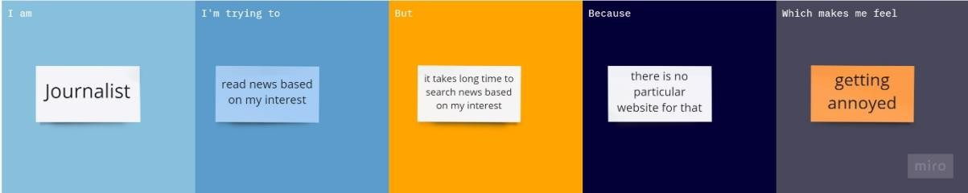

|  |  |  |  |  |  |
| --- | --- | --- | --- | --- | --- |
| **Problem Statement (PS)** | **I am (Customer)** | **I’m trying to** | **But** | **Because** | **Which makes me feel** |
| PS-1 | Employee | Get updates on latest news and affairs | There are too many news out there so it get  really confusing | But there is no free time | Not updated on the news |
| PS-2 | Student | Get news update on my phone | Need filter option or suggestion on my taste | I need a faster way than reading the  news paper | Excited for there applications |
| PS-3 | Reporter | Report misleading news | I am unable to do that | But there is no ways to report  these news | Implementation to customer care necessary |